Journal Article
Journal | Wind Engineering
Publisher | Multi Science Publishing
ISSN | 0309-524X (Print)
Subject | Renewable Energy and Wind Power
Issue | Volume 38, Number 2 / April 2014
Category | Research Article
Pages | 217-232
DOI | 10.1260/0309-524X.38.2.217
Online Date | Tuesday, May 20, 2014

The Flutterwing WindPumps: Design, NonLinearities, & Measurements
S. P. Farthing www.econologica.org spfd@cantab.net

Abstract
A preceding linear stability analysis showed that the pitch and roll flutter of a wing can stop in high winds. The built-in protection and variable stroke motivated development of a flutterwing windpump, because rotors pumping with a fixed stroke usefully convert only 10% of the Betz limit of the wind’s annual power. Here the stroke has to be negligible at small roll not to stiffle the start of flutter in the lightest of winds, but ultimately must increase fast to safely limit the roll amplitude by absorbing all the power of the strongest oscillation. It must be largely single-acting, just as for a piston pump down a deep well, to allow a suddenly-becalmed wing to return to vertical and then restart with a new wind. The more non-linear the pump’s stroke, the larger its stiffening side effect. Other non-linearities at large amplitude include the apparent wind, the centrifuging effects of roll speed and the saturation of pitch. Smoke observation of light wind flow at full +/-90º tangent pitch shows remarkable stall delay until at the end of the roll swing the leading edge sheds a massive vortex to completely reverse the wing circulation. Such a wide vortex street maximises the swept area in the actuator limit where tangent blades of constant chord keep constant circulation between stalls. Runaway of frequency and amplitude with windspeed is avoided by static gravity imbalance replacing some dynamic imbalance and the inertia and softening of a gravity pendulum, both as favoured by large scale and low design windspeed. Also helpful are not too high pitch inertia centrifuging and an aircushion on the output pipeline which reduces the stresses and pipe frictional loss as well as the pump stiffening. Then in moderate winds, the pitch can unsaturate and the wing start to feather at lower reduced frequency, containing the power and especially the downwind bending moment. In higher wind the wing then becomes stable just leaning with the wind veer. The niche is pumping as much as the prairie rotary windpumps of diameter equalling the wing length, but with only ½ of the mean wind or 1/8 the mean windpower density, and with much less material. Both floating and well bases and pumps have been developed for the same pendulum, wing, and nonlinear pump winch.

Keywords- Binary Flutter; Aeroelastic Instability, Waterpumping Windmill, Windpump, Multiblade

- INTRODUCTION
A linear stability analysis [1,2] found all the neutral stability contours of a foil free to pitch and elastic in heave pass through a feather point of total pitch inertia and imbalance the same as for the virtual mass at the ¾ chord point. A practically constructed hydrofoil is not heavy enough relative to the water to achieve these critical flutter values, not helped by the extraordinary low virtual intrinsic inertia about midchord. But a (much) heavier-than-air wing can start to flutter in light winds . 3D semi-rotary roll instead of the impractical linear heave oscillation eliminates the 2D quasisteady divergence/flutter mode of feathering in the apparent wind of heave and very high windspeed [2], so that roll/pitch flutter stops in storms, and the wing just pitch feathers to the true wind blast. This built-in protection motivated development of a light fluttering windpump with its variable stroke…
Rotary windpumps would need starting clutches and variable stroke to achieve the same fraction of swept wind energy capture as windgenerators [3] . Without a clutch the blade area A of a windrotor of radius R must almost equal the swept area S=πR² to produce the high swirl for enough torque ½ρV²SRC_{Q} to turn over the pump crank. The optimal starting X=0 torque C_{Q}= ½√3=.87 at interference a= ¼ causes a tangential reaction velocity of ½√3 windspeed V which continues outward without centripetal constraint into the tip vorticity [4] with a power loss of all the lateral kinetic energy flux $\frac{9}{16}$½ρV³S (or the nominal 2D C_{P}= 4a(1-a)² $=\frac{9}{16}$.)
Rotation decreases the blades’ angle of attack and interference; and at tip speed ratio X=1 the useful 3D C_{P} peaks at .3 (or .6 the BEM X=1 ideal of ½ at a=.32 ) . Then C_{Q} =.3, reduced by a factor of 2.9 from the starting torque. Deep well pumps are single-acting with peak starting torque π > 2.9 times the mean torque, so in enough wind to start, the rotor overspeeds past its best X=1. With the wind torque scaling as wind squared, and the (useful) pumping torque constant with the fixed stroke, with more wind the rotor overspeeds to even more non-optimal high X and the high drag loss from its high solidity cambered plates increases. The gyroscopic loads may then so high as the tailvane furls the over-speeding rotor of many heavy sheet metal blades in excess winds, as to require simultaneous rotor braking. All told the typical annual pumping work averages to 1/10 of the Betz ideal [3]. It is these huge structural, weight and power inefficiencies that justify considering variable stroke reciprocation of the pump instead by the flutter of a large light weight hollow uni-blade free to pitch around the top of a pendulum[5].

2. Wing Design

Due to the low wind loading and inertial fatigue penalty of weight [1], the uni-blade was constructed like a slow airspeed wing, as the Figure 1 fabric-on-frame of western red cedar sp gr .32. The tapered spars are widest ahead of the top of the pendulum axle at 23% chord. A 16% Joukowski symmetric airfoil is thicker further forward than a NACA0016 to give a stronger and stiffer spar separation. Wood angle sections between each spar and the triangular leading edge have flanges cut to the strong curvature on each side of the leading edge.
The spreader of an external diamond stay passes behind the spars at the top of the axle. Below is a thin diagonal-cut plywood shear web between the aft spar edges and above an angle bead truss, progressively more oblique towards the tip to save weight. The rear ribs of angle bead wood are canted , reducing their low Joukowski bend, into a vertical truss tied to the shear web to give the wing high torsional stiffness . The layering of the metal flakes in aluminium paint gives excellent UV protection to the cheap fused woven polyethylene (lumber wrap) fabric which is heat shrunk tight. The 18’ long wing of chord c= 4.5’ has weight MG=40lbs centered h=14’ above the axis of roll φ .
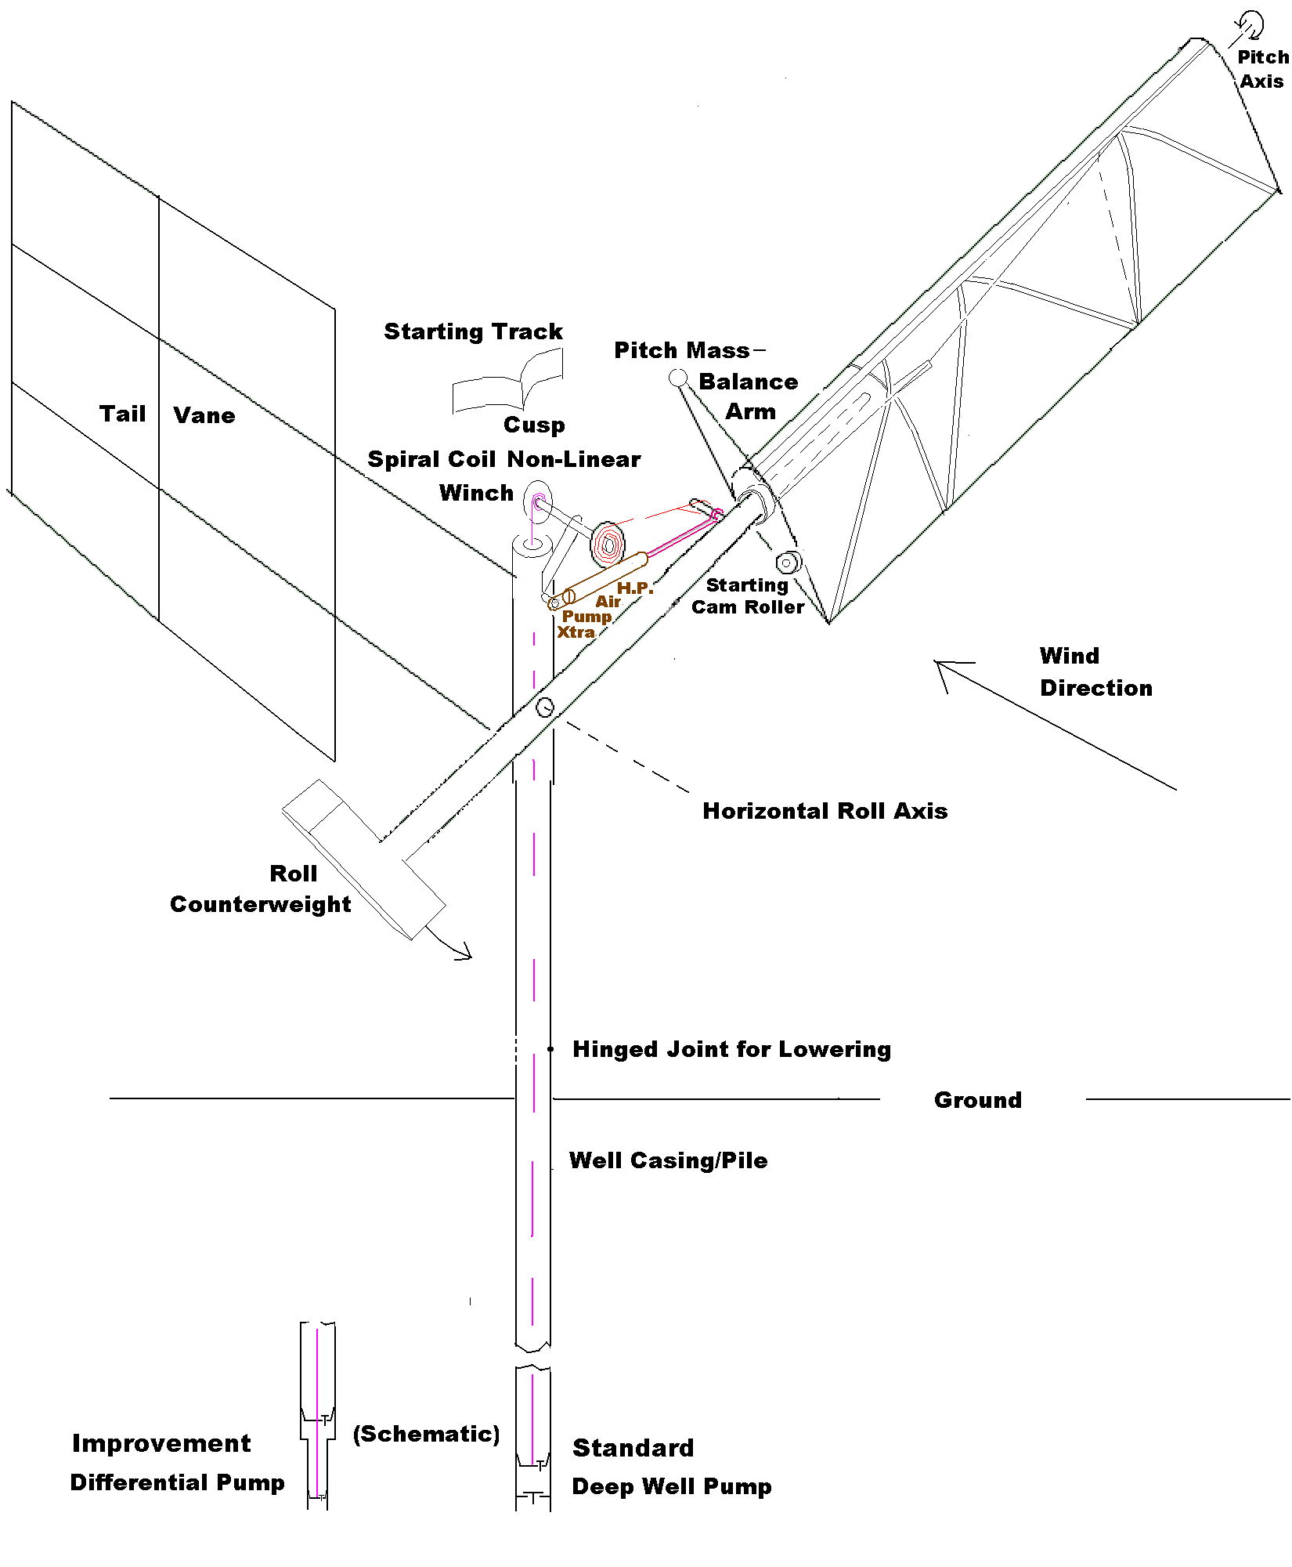
Figure 1 Flutterwell Pump (typesetters NB: repeat of Fig 3 in previous paper p492 vol37)

The outside wing root is a pipe which rotates around rollers on the pendulum top axle, with tracks (not shown) on the outside of the pipe [5] so that a cam lever from below can center the wing to zero pitch to stop the flutter. The present wing has its pitch axis at 21% at the root and at 26% at the tip. This sweepforward gives a slightly negative cross inertia about its c.g. and further improves high wind cutout by increasing the (cross) determinant [B,C] of aerodynamic damping B and stiffness C matrices [1,2]. The small mean trail e of 1.5% of the ¼ chord center of pressure minimises the amount of pitch counterbalancing and net pitch inertia. The pitch partial counterbalance was mounted forward of the wing root to minimise its roll drag and its wing bending moment at the price of reducing its dynamic balancing. This carpeted wood plank maintains about the same pitch imbalance in the rain as the water pickup of the wing fabric is minimised by its alkyd aluminum paint . The pitch inertia was real R_{γγ} =181 plus virtual 42 for a total I_{γγ} =223 lbsft².
The wing pitch bearings must bear the wing weight in starting but also a separating axial force for the entire cycle once φ_{o}≥ 90 and the peak centrifugal acceleration φ_{o}²hω²>gravity G or as ω²≈MGy/R_{φφ} when
φ_{o}²h> R_{φφ/} /My= k²/y (>y) (where M is the pendulum (plus wing) mass, y its cg below the axis and real roll inertia R_{φφ} =Mk²) .

3. Pump Power Takeoff - Design and Dynamics
Just as in rotary windpumps, the pump dominates the design, firstly in the choice between the linearly-equivalent planar and spherical pendula. Sphere-on-horizontal-ballrace models oscillated well in any wind direction even with an advantageous figure of eight blade motion if of less than 90º roll. At full scale such a spherical joint would have too much pitch friction and counterweight pitch inertia. Instead the wing alone pitched and the pendulum was suspended on diagonal springs to a paralleogram frame of four equal sides, but at full scale stroking a pump with the pendulum’s pull away from vertical triggered avoidance by a conical pendulum mode (faster with a complicated pitch cycle that included a tailwinded divergence). The next pendulum had two perpendicular roll hinges with two further hinges in a parallelogram to a ball joint atop a copy arm with a small tailvane and a horizontal (wind) axis, whose yaw was only allowed near vertical. Finally and more simply a planar pendulum capable of larger roll amplitude was entirely yawed into the wind about the vertical pump axis by a large tailvane. On land in Figure 1 this had to be three sheets of plywood to counter the yaw torque from the downwind thrust on the rolled wing.
The increase of flutter roll/pitch amplitude ratio with windspeed [1] confirms the flutter should be tapped from the easier roll, not pitch. The return pump stroke work must be less than the pendulum energy so as not to prevent a return to the equilibrium starting position should the wind suddenly die. The standard deep well single-acting pump indeed has no downstroke work. Suitable for minor return stroke work is compressing an air stroke volume sucked in on the prior swing away from vertical. The piston bottoms in the cylinder as the wing passes through vertical, ensuring complete exhausting of the air compressed, as in Figure 1. Whereas the main away-stroke output fluid cannot be air because of the extra roll stiffness and heat loss of re-expansion of any air remaining from a partial output stroke. Likewise windrotors have accentuated starting problems with a single acting compressor (unless a centrifugal loader (clutch) is built in.) For 100% high pressure air compression, the Wing’d Pump can drive an aircompressor from a spiral output chain so its variable stroke is a sum of many completely-bottoming aircompressor strokes. For instance the chain can drive the sprocket of a scrap motorcycle engine with its clutch converted to a ratchet, and its piston extended to push and pull the unsealed rods of opposed pistons in staged, intercooled cylinders.[6]
To not inhibit flutter starting in light winds and building power as amplitude squared (in linear theory) but to contain the roll amplitude in stronger winds, the power connection to the water pump must have a stroke increasing non-linearly with roll. A naïve constant-frequency criterion is the roll amplitude φ_{o} should vary as windspeed to keep the same tipspeed ratio and so maximum C_{P}, so then the power ie pump stroke should vary as windspeed cubed times swept area so as φ_{o}⁴. But C_{P} peaks at a low windspeed and an absolute power, and the frequency does rise, and φ^{2.7} proved adequate.
Such a nonlinear single-acting pump is much more in Fourier phase with roll than with roll velocity so its stiffening side effect exceeds its damping purpose. For the actual pump backtorque P as φ^{1.7} the stiffening Fourier component in-phase with roll is 1.88 the out-of-phase damping component . Whilst the consequent rise in oscillation frequency with load at amplitude helps meet the load with more power, the roll amplitude, frequency, power and stresses must have definite upper limits. The pendulum safely latches out in an over-roll. But the first excess roll will pull the zeroing lever to reduce the pitch. On the floating version (Figure 7), a pole forward of the wing tip will also dip in the pond and its towel wrapping absorb water to temporarily reduce the dynamic imbalance and so the amplitude.
With large wing radius R>> V_{d} ² /G and light design wind V_{d} [1], the frequency rise can be minimised by counterweighting the pendulum for more roll inertia R_{φφ} than counterspringing and by the decrease of gravity stiffness and natural frequency with amplitude, whereas most practical spring geometries stiffen with amplitude. The larger the roll inertia, the larger the matching roll potential energy and the greater the de-stiffening return stroke work it can overcome to bring the pendulum back to vertical if the wind dies. So the pendulum weight needs to be at maximum (clearance) radius for maximum (low-stress) inertial benefit.
The pump non-linearity gives the instantaneous pump acceleration and velocity head large maxima just before roll peaks, necessitating an aircushion more than twice the maximum stroke volume before long delivery pipelines to prevent high transient line inertial and friction heads adding to the static. Most significantly at low head and high flow rates, the flow friction head scaling as velocity squared can especially raise the pump stresses and stiffening besides wasting power. Also any non-ideal give in the power takeoff such as by the heel of a floating base effectively adds stiffness at no extra pumping.
The spiral winch coil is unwound by the pull of the pendulum outswing, decreasing the coil diameter so the revolutions increase sharply. Conversely as these turns wind up the coil of the pump belt, its movement increases sharply, so the stroke and back torque increase doubly strongly with roll. Wing’d stands for Wind Wing Winding Pump. The slow angular semi-rotation of roll is being converted to multiple revolutions of the winch and thence to linear motion of the pump. A ring gear on the winch can drive a starter pinion ratcheting a car star-wound alternator fast enough to charge batteries on the side. (The controller regulates field voltage for economy as well as sufficient rpm and then the output voltage.) The winch axle is offcenter to make the pull on the upright axle more vertical to partially match small strokes and to equalise the extreme axle rotations and so pump strokes.
With the actual 3D radial variation of heave h=rφ, pitch moves the wing real mass elements further from the roll axis slightly increasing their real roll inertia. The net roll equation integrating the 2D virtual and quasi-steady circulatory forces resp. from (A3) and (A4) of [1] is

φ”(I_{φφ}-Dsin² γ)-γ”I_{φγ} cosγ +γ’²I_{φγ} sinγ -Dγ‘φ’sin2γ-γ‘Vcos2γ∫mrdr+MGxcosφsinγ+MGysinφ+P =∫rdrπρΤVc{Vsinγ−rφ’cosγ+(ε+½c)γ‘} (1)

where I_{φγ} is the total cross inertia, I_{φφ} is the total=real R_{φφ} + nominal virtual roll inertia∫mr²dr, m=¼πρc² the added mass per unit span, and D= ∫mr²dr- R_{γγ} the difference between the virtual roll inertia and real pitch inertia R_{γγ} which ∫mr²dr dominates by the square of the aspect ratio >> the mass ratio even in air. In fact the net virtual inertial force normal to a section varies as the upwash U , so the net virtual heave inertia is actually negative when γ‘Vcos2γ∫mrdr is included ; though linearly, the net fluid effect is reversed again to positive inertia by the RHS circulatory lift force with the phase shift θ <90º [2]. If the c.g. is pitched out of the vertical plane, MGxcosφsinγ is the gravity roll moment where MG is the wing weight at distance x behind the pitch axis .

4. Pitch Distorting Non-Linearities

The 3D Lagrangian further gives a centrifugal pitch moment ½R_{γγ} φ’² sin2γ from the roll centrifugal force trying to throw the wing to +/- 90º pitch to put the real wing planar mass elements furthest from the roll axis for maximum instantaneous real roll inertia. The 3D generalisation of the pitch equation (A4) in [1] is thus

I_{γγ} γ” -φ”I_{φγ} cosγ - ½ R_{γγ} φ’² sin2γ + MGxcosγsinφ = -γ‘∫m(Vcosγ+r φ’sinγ) (ε +½c)dr -∫drεLcosTα_{¾} (2)

The roll distortion and frequency increase by the pump increase the peak and mean φ”I_{φγ} cosγ dynamic forcing of pitch by roll fling. The critical dynamic imbalance I_{φγ} for cutout is also lowered directly by the pump stiffness extending the resonance of roll stiffness with the pitch stiffness rise as windspeed squared [2].The safer gravity G static forcing MGxcosγsinφ scales as GR / V_{d} ² times the dynamic. Both imbalances force pitch as the cosine of its angle γ, but static gravity also as the sine of the roll φ for extra attenuation with amplitude.
The wind factor in the dominant explicit pitch damping is generalised to the nominal chordwise apparent wind Vcosγ+r φ’sinγ . At the nominal θ =90º r φ’sinγ decreases at the extremes of the roll motion vs. the peaks of roll velocity r φ’, so the pitch is expected distort to concentrate its change at the roll peaks. Near γ=0 the centrifugal term can more than double the effective pitch inertia when R_{γγ} φ_{o}²> I_{γγ} ie φ_{o}> 1, again extending the resonance. As importantly with θ <90º the centrifugal term forces pitch by heave, the most at θ=45º. The non-linear r φ’sinγ damping is reduced by a phase shift θ significantly different from 90º .
Such pitch-distorting effects, the difficulty of analysing dynamic stall and the influence factor T for a non-linear=non-planar wake, and the scaling limitations of models [1] required building full-scale prototypes and directly measuring their pitch in large amplitude flutter.

5. Measurements and Flow Visualisation on Instrumented Prototype vs. Windspeed
Inserted down the overflowing top of the pump riser was a custom propeller flowmeter (calibrated on an Armfield hydraulic bench). The test well had a full steel casing sealed at the bottom to maintain a constant 36’=11m head. A digitised vane anemometer, calibrated by a mine ventilation safety service was 7’ forward and 7’ above the pendulum axle (itself 12’ high). A data card in a PC recorded the signals and iterated the windspeed as in Appendix B..

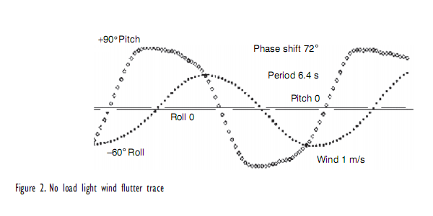
The starting pitch damping is low with the low windspeed, so roll over-forces pitch, and linear flutter analysis [1,2] correctly predicts close to pure pitching (about the ¾ chord point) at high reduced frequency of
k= ωc/V =1.2. With the tail heavy at most by 1.5 lb, the pitch saturates at +/90º in the starting windspeed of 1m/s and flips very quickly. Figure 2 shows the pitch to 90º, often even beyond, and a slow relaxation during the roll traverse and then the sharp reversing overswing at the end of roll , with a zero-crossing phase lead of about 72º.
Smoke was pumped up ducts to exhaust at the nose and tail, to look for blade stall at such high pitch. Wings greater than 15% thickness/chord had attached tuff flow for most of the cycle. In the lightest wind of .8m/s the ends of the roll stroke have truly dramatic flow, as the Figure 3 video stills show. The leeward boundary layer, hitherto attached despite the very high angle of attack, is finally beginning to separate at the nose with a large vortex growing on the suction side of the leading edge. Roll reversal can begin with the wing near full pitch γ=90º, tailup. Then there is an interval of trailing edge-first flow which must generate tremendous diverging pitching moment about the front pitching axis, with negative explicit pitch damping from the negative chordwise apparent wind. Despite the sharp trailing edge at extreme angle to the true wind, the new reverse boundary layer remains attached right back to the nose where the huge vortex is shed away from the downwind and outward side. This “dynamically delayed” stall vortex is so big that its detachment seems to completely reverse the wing circulation as none of the trailing edge shedding of linear theory is seen. The self-wind part of the explicit pitch damping rate or rφ’sinγ (ε +½c) remains negative until γ crosses 0. The static and dynamic imbalances act strongest around γ=0 to continue the pitch (negative) acceleration. Past γ = 0, the centrifuging by the increasing roll velocity on pitch inertia begins, peaking at γ = -45º. Finally pitch inertia can carry the γ motion beyond -90º taildown equilibruim of no pitch forcing or centrifuging. Then the wing can remain at near-constant new angle of attack to the ¾ chord apparent wind or at constant new circulation as the decay of the pitch overshoot to tangency coincides with the decrease of the induction from the shed vortex with separation.

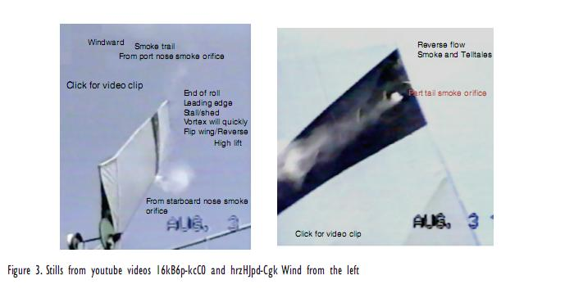
So vortices are shed at the extremes of the roll motion for a wake with the widest swept area. In the 2D actuator limit of Appendix A , multiple constant circulation blades can reach the Betz power whatever their crosswind path or acceleration. The circulation is constant for (stall-free) tangent (+/-90 º) blades and their interference a equal to the reduced frequency l= ½k=ωc/2V (A4), indicating very crudely that a uniform chord c is close to optimal despite the (semi)rotation. Such a constant airfoil chord is easiest to construct, particularly with constant section. The strong increase of the dynamic flip and flow reversal impulses towards the tip vs. the more uniform distribution of pitch inertia (mainly from the trailing edge and rear ribs) explains why high torsional rigidity was found to be critical. If the pitch could not reach almost 90º due to twist flexing or (staying the wing like a mast) the power was visibly lowered. l decreases almost inversely with windspeed, and the actuator interference a even faster than l as the pitch begins to unsaturate.
The scatter and data collection time of measurements versus windspeed were greatly reduced by the wind transform described in Appendix B, which would be applied to any site data to predict the windpump’s performance. The pumped power P in Figure 5 increases as almost offset linear with effective windspeed V until levelling off as the pitch amplitude unsaturates and eventually falling as the wing feathers in high winds. The peak delivered P/V³ point is then at 3/2 the offset or here 2.29m/s. C_{P}=.21 based on +/-45º swept area from Figure 6 for the current 18’ wing starting 7’ above the axle. With pump friction and volumetric net efficiency of ⅔, the raw C_{P} would be about .3 or ½ the Betz limit. (Taking the roll amplitude variation into account the peak C_{P} would be a bit higher at a bit lower windspeed and roll amplitude.) Here at rms X=3.1, l =.4 correctly a bit more the optimum actuator interference a=⅓. Naively the optimum aspect ratio as R/c=X/k =2X/l is determined by this optimum l (k=1.2’s safety margin below the linear f=2 in Fig 2 of [1]) and the optimum (peak) X from the apparent wind, drag and (actuator) tip effects.
Six different full-size rectangular wings with different thicknesses and lengths 14’-19’, with the chord mostly the maximum 4.5’ adult overhead lift span, were tested with the same gap of 7’ between wing and roll axis. The longer wings of higher X for the same k had better C_{P} and also more definite cutout in high winds.

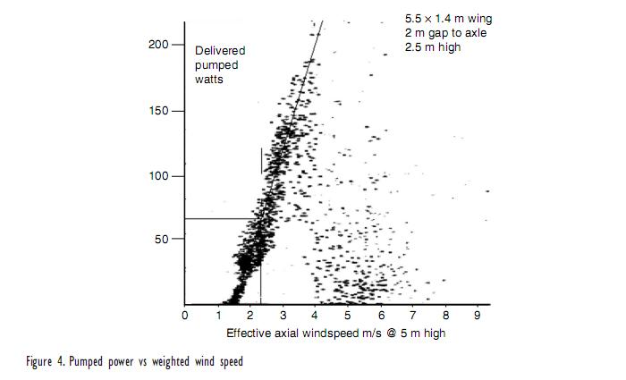

Figure 4 Pumped Power vs Weighted Windspeed

The peak absolute power point is at about 4.5 m/sec or about twice windspeed of peak C_{P} (eg Figure 4) with about 4 times the output or 1 USG/s at 18’ static head. As the wind strengthens, the large pump torques distort the roll peak (Figure 5) with faster deceleration of the outward swings with a net increase in frequency. Even linearly without the pump, 3D flutter calculations [1] show an increase in frequency from cutin to cutout with the approach of the phase shift to 90. The increase of pitch damping with windspeed and frequency reduces the pitch overshoot . The stronger centrifuging at the roll velocity peak stops the undersaturated pitch relaxing, so the smaller pitch wave is squarer. 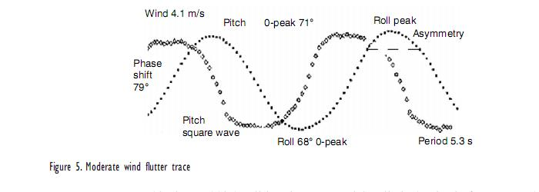

Pump output cushioning and high roll inertia are essential to limit the rise in frequency whose square is the dynamic imbalance flinging the wing pitch harder versus the linear in frequency (and windspeed) pitch damping. Also the centrifugal forcing varies as frequency (and roll amplitude) squared at a given phase shift versus the damping torque as the first power of frequency, pitch amplitude, and windspeed. If the frequency and roll amplitude don’t increase too much with windspeed, then the pitch damping dominates and the pitch amplitude can decrease which strongly reduces the downwind bending moment and contains the power. Also essential as in linear flutter is the growth of the pitch aerodynamic stiffness with V ² despite the small ε's. With a constant enough frequency, it overcomes the centrifugal divergence and mismatches the pitch inertia to depress the pitch amplitude. Figure 6 shows typical flutter parameters vs weighted windspeed; note the drops in period and pitch amplitude.
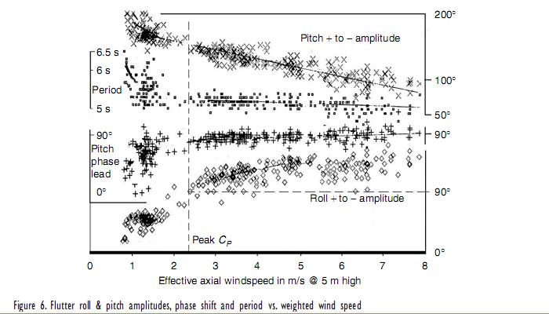
Figure 6 Flutter Roll & Pitch Amplitudes, Phase shift and Period vs. Weighted Windspeed
With a strong enough gust, the wing return at the gravity frequency to vertical can be interrupted by the tendency to lean in strong veered winds[1]. The pitch (aerodynamic stiffness) torque on the upper ⅔ wing at say positive angle of attack to the upper wind is matched by the torque on the lower ⅓ wing at negative angle of attack to the lower wind and bigger trail, but the upper wing has greater roll torque, so the wing leans away from the upper wind and into the lower. So locking the roll in high winds is difficult and causes more bending stress than leaving the wing free to lean. Reversal of the veer and so lean can’t initiate flutter because of the high wind pitch damping and stiffness. In very high winds the pitch reaction to shifts is very fast and overdamped with none of the overswing or roll resonance that begins flutter in light winds. Built-in wing twist has a similar effect to veer and in operating winds can cause marked asymmetry of the roll.
To summarise the dynamics, the predominant non-linear observation is the square wave in pitch, saturated in light winds with some tailfirst flow, from the loss of explicit pitch damping at the roll maxima and pitch divergence due to roll centrifuging of the pitch inertia which also forces pitch at the low starting phase shift. This non-linear state needs very little pitch imbalance and causes hystersis in light wind cutin and even high wind cutout. The necessary non-linearity of the pump causes the frequency to rise with amplitude. So the increase of roll centrifuging (torque)as pitch inertia times by the square of roll amplitude and frequency , and of pitch forcing by imbalance times roll amplitude by frequency squared must be small enough to be dominated by the increases in pitch aerodynamic damping with true windspeed, pitch amplitude and frequency, and in pitch stiffness as windspeed squared and amplitude. Then frequency and roll amplitude runaway is avoided and the flutter stops at say 10m/s above which the wing leans with the windshear with quick over-damped response to its changes.
To reduce delays in self-starting, the bottom of the wing has a cam wheel at about 35% chord. The cam track is at the top of a ply sheet (not shown in Fig 1) which is spring hinged at the bottom to blow back out of contact in high winds. In no wind the track forces the wheel to one side of the axle, pitching the wing. A rising wind drives the wing across with increasing pitch until it swings over the cusped crest of the track and then is pitched the other way to drive the pendulum back. Once the oscillations build there is no normally no contact. This starting track is vital in directionally stable winds such as seabreezes with weak windshifts and helpful in intermittent winds such as generated by thermals or sideflow around bluff flow barriers such as forests.

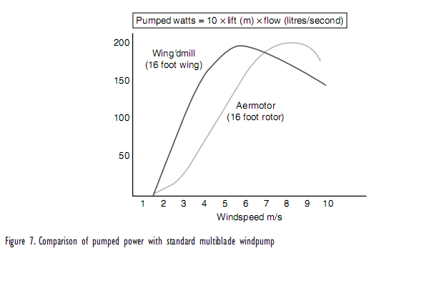
The absolute C_{P} is of little import without at least removing the φ factor in swept area, which is only limited to +/- 100º say. For comparing with fanpumps the true measure is the cost of windmill, pump and reservoir for a desired (seasonal) output and minimum supply for a given wind regime. The reservoir size and cost is decreased by the lighter starting windspeed. The structural cost reflects the peak lift and drag bending moments, here with a fatigue endurance factor of about ½ for steel (better for wood). Wing and axle stresses peak as the stroke ends when gravity and strong pump bending moments coincide. It is stronger for the counterweight and even the pump pull to be decelerating a high inertia counterweight rather than a high inertia wing. Then the wing is passing peak aerodyanamic power into the counterweight’s inertia as they cross vertical.
All told, roughly the same length wing as diameter fanmill will pump the same water in about ½ the windspeed ( or 1/8 the windpower flux) as in Figure 8 at much less structural weight and cost of materials. The moving parts are much nearer ground level to be easier and safer to service, with the pumps [5] described next..

